A telomere is a region of repetitive DNA at the end of chromosomes, which protects the end of the chromosome from destruction. Its name is derived from the Greek nouns telos "end" and merοs "part".
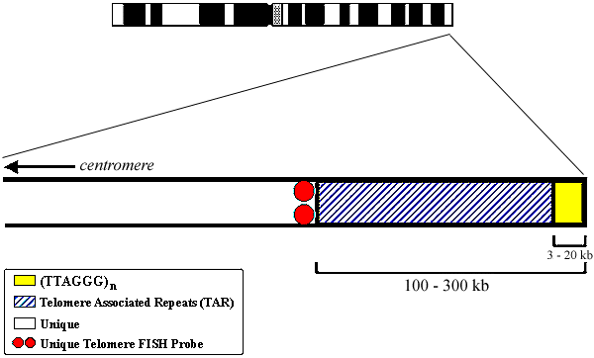
Telomeres extend the life of the DNA molecule.
During cell division, the enzymes that duplicate the chromosome and its DNA cannot continue their duplication all the way to the end of the chromosome. If cells divided without telomeres, they would lose the end of their chromosomes, and the necessary information it contains. The telomeres are disposable buffers blocking the ends of the chromosomes, , and are consumed during cell division and replenished by the enzyme, the telomerase reverse transcriptase

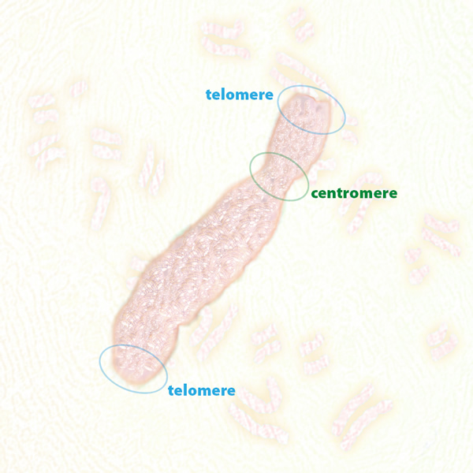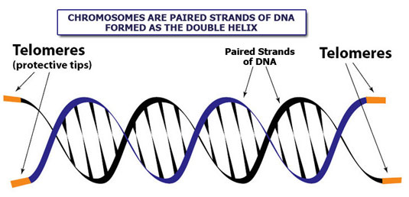

Centromere is made of satellite DNA and protein.
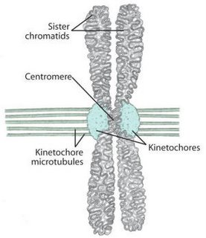
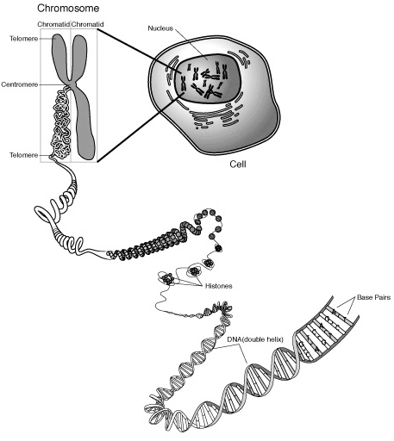

What is a restriction enzyme?

Restriction enzymes are proteins produced by bacteria to prevent or restrict invasion of foreign DNA.
Restriction enzymes are endo-nucleases that cuts the phospo-diester bonds within the DNA molecule.

Nuclease- any enzyme that cuts phosphodiester bonds of DNA.
Exonuclease- a nuclease that cuts the DNA starting at a free end and working in.
Endonuclease- a nuclease that cuts the DNA molecule somewhere within the molecule(cuts phosphodiester bond)
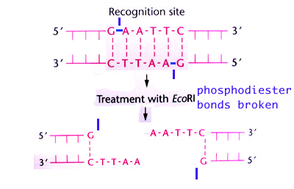
Restriction enzymes were originally discovered through their ability to break down or “restrict” foreign DNA .

Restriction enzymes recognize and cut at a specific nucleotide base sequence called “ restriction site”.
In general the restriction enzyme recognizes between 4-6 base pairs. 5’GAATTC3’ is the restriction site for the enzyme EcoRI.

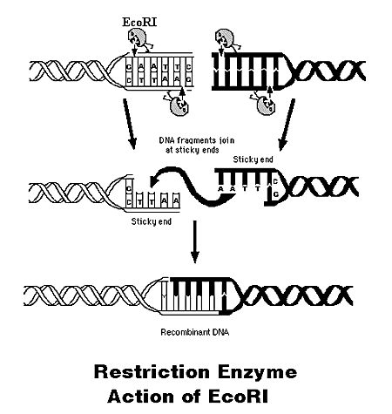

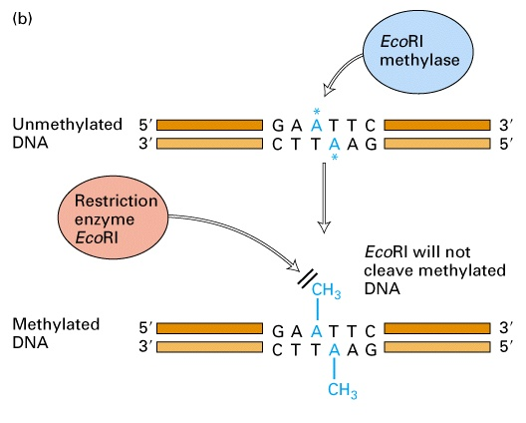

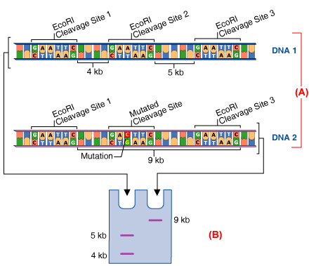
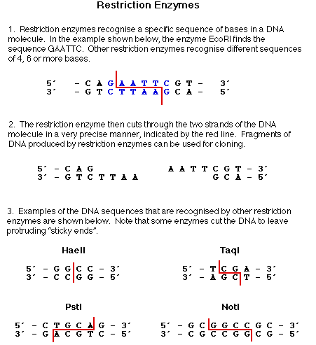
The TATA box (also called Goldberg-Hogness box) is a DNA sequence found in the promoter region of genes in archaea and eukaryotes; approximately 24% of human genes contain a TATA box within the core promoter.
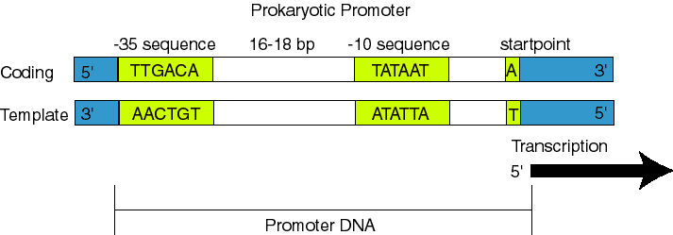
Considered to be the core promoter sequence, it is the binding site of either general transcription factors or histones (the binding of a transcription factor blocks the binding of a histone and vice versa) and is involved in the process of transcription by RNA polymerase.
The TATA box has the core DNA sequence 5'-TATAAA-3' or a variant, which is usually followed by three or more adenine bases. It is usually located 25 base pairs upstream of the transcription site. Believed to have remained consistent throughout much of the evolutionary process, possibly originating in an ancient eukaryotic organism.
It is normally bound by the TATA binding protein (TBP) in the process of transcription, which unwinds the DNA, and bends it through 80°. The AT-rich sequence helps with easier unwinding (due to weaker base-stacking among A and T than G and C).
The TATA box is usually found as the binding site of RNA polymerase II.
Most genes lack a TATA box and use an initiator element or downstream core promoter instead. Nevertheless, TBP is always involved and is forced to bind without sequence specificity. A genome-wide study put the fraction of TATA-dependent human promoters at ~10%.
An earlier study of ~1,000 genes found 32% of the promoters had a TATA box.

