UNIT 9 PROTEIN SYNTHESIS
DNA contains genetic information to produce RNA which governs the production of Proteins.
"The Central Dogma of Molecular Biology"(Francis Crick)

States that information flows through macromolecules
1. DNA => mRNA => protein
2. also includes DNA replication
Retro-viruses such as HIV, have now shown that this is not always the case. ( they do not follow the central dogma)
reverse transcription codes backward (mRNA => DNA)
sometimes mRNA --→ mRNA
possibly Protein--→ mRNA (prions)
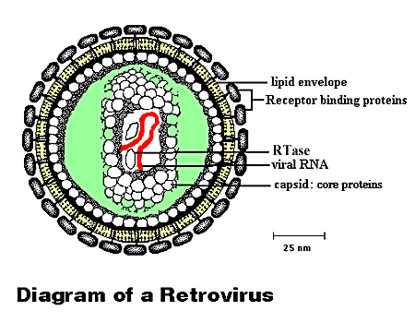
Retroviruses contain RNA in place of DNA. In addition to RNA, retrovirus particles also contain the enzyme reverse transcriptase (or RTase), which causes synthesis of a complementary DNA molecule (cDNA) using virus RNA as a template.

1940’s Beadle and Tatum
Discovered in bread mold ( conclusion : genes were responsible for production of different enzymes and proteins)

Gene Expression : form of gene that shows up in the phenotype of the organism
Genotype
Phenotype

Gene: a specific length of DNA that serves as a functional unit 70- 100ntb
- Structural genes:
Code for body enzymes and proteins
- Regulatory genes
-Function to control activity of other genes
- Determine whether a structural gene will be expressed

RNA STRUCTURE AND TYPES:
- Single strand of nucleotides
- Consists of Ribose- phosphate- base
A, U, G, C

Three types of RNA
- mRNA: messenger
carries the order of AA from the DNA to the ribosomes where proteins are made

- t RNA : transfer RNA
carry the AA(amino acid to the Ribosomes to be put together
(anticodon) (aminoacyl attachment site)
- rRNA : ribosomal RNA
-major component of ribosomes
-1 rRNA molecule recognizes the beginning of the message in mRNA

4. RNAi : RNA interference ( quiets DNA at the translation level)
a.A microRNA (abbr. miRNA) is a small non-coding RNA molecule (~22 nucleotides) found in plants and animals, which functions in transcriptional and post-transcriptional regulation of gene expression. Encoded by eukaryotic nuclear DNA, miRNAs function via base-pairing with complementary sequences within mRNA molecules, usually resulting in gene silencing via by blocking the translation of mRNA or target degradation of polyA tail. The human genome may encode over 1000 miRNAs, which may target about 60% of mammalian genes and are abundant in many human cell types. ( BLOCKS TRANSLATION OF MRNA)
b. Small interfering RNA (siRNA), sometimes known as short interfering RNA or silencing RNA, is a class of double-stranded RNA molecules, 20-25 base pairs in length. siRNA plays many roles, but its most notable is in the RNA interference (RNAi) pathway, where it interferes with the expression of specific genes with complementary nucleotide sequence. siRNA also acts in RNAi-related pathways, e.g., as an antiviral mechanism or in shaping the chromatin structure of a genome. The complexity of these pathways is only now being elucidated.

TRANSCRIPTION AND TRANSLATION

Transcription :
Process in which the DNA molecule is used as a
- template to make an RNA molecule
- 3 basic steps in transcription
- 1. Initiation 2. Elongation 3. termination
- Initiation : binding of RNA Polymerase to one DNA strand:
- TATA box : site of RNA Polymerase binding
in many eukaryotic genes 5’-TATAAA-3’ this strand has remained constant thru time
( evolutionary significance )
- Elongation: RNA polymerase reads one strand of the DNA and puts nucleotides together
  - Termination: RNA polymerase comes to a termination codon
Translation:
The synthesis of a protein from RNA .
- The Nucleotide language is translated into Amino acid language
- The nucleotide language is a base triplet code
- mRNA = codon T-A-C : tRNA = anticodon A-U-G

The majority of genes are expressed as the proteins they encode. The process occurs in two steps:
- Transcription = DNA → RNA
- Translation = RNA → protein

ONLY ONE STRAND OF DNA ACTS AS A TEMPLATE FOR THE COMPLEMENTARY STRAND OF RNA
Here is an overview.
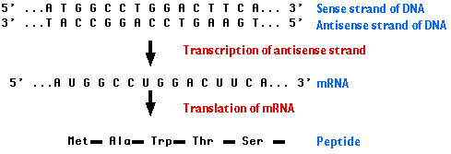

Removal of the introns — and splicing the exons together — are among the essential steps in synthesizing mRNA.

The steps of RNA processing:
  - Synthesis of the cap. This is a modified guanine (G) which is attached to the 5′ end of the pre-mRNA
  - protects the RNA from being degraded by enzymes that degrade RNA from the 5′ end;
The 5' cap has 4 main functions:
- Regulation of nuclear export.
- Prevention of degradation by exonucleases.
- Promotion of translation (see ribosome and translation).
- Promotion of 5' proximal intron excision
  - is an assembly point for the proteins to begin translation.
- Step-by-step removal of introns present in the pre-mRNA and splicing of the remaining exons.
Introns are removed by enzymes known as splicosomes or (snRNPs)
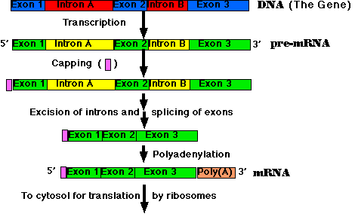
- the poly(A) tail is attached to the exposed 3′ end. This completes the mRNA molecule, which is now ready for export to the cytosol.

Poly a tail is @ the 3’ end and is a series repeating adenosines nucleotides (up to 300bp ) that help the mRNA with stability and be more easily translated
5’ Cap is much smaller but has the same function as the poly a tail
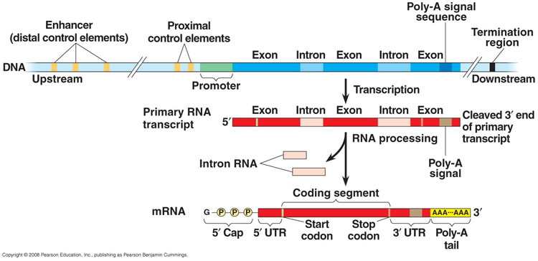
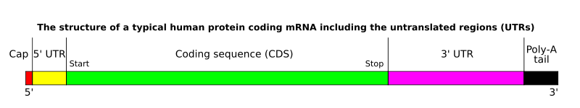
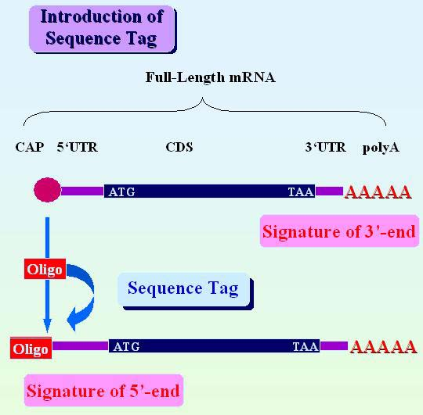

Note: DNA in eukaryotes never leaves the nucleus
RNA does leave the nucleus
Note: RNA acts as a go between between DNA and ribosomes.
Note: Ribosomes found in the cytosol on the RER.

GENETIC CODE:
- Is a triplet code
- mRNA triplet code is called a codon
- there are 64 codons possible
- 3 of the 64 don’t code for Amino acids: they are stop codons UAA, UAG, UGA
- 1 start codon AUG – for the amino acid methionine
There is more than one codon for most AA. therefore the code is said to be degenerate.
This is a redundant factor and can cause “silent mutations” pg 64 old book
This redundancy factor reduces the # of harmful mutations.
Frameshift mutation:
Know diagram pg 165 fig 10-41

Prokaryotes DNA in cytoplasm as the mRNA is transcribed ribosomes attach and proteins are made.
Eukaryotes : very different
RNA transcribed in the nucleus , then (guanine) cap added introns removed then mature RNA moves to the cytoplasm and the RER.
Mature RNA has a special cap attached to the 5’ end and the tail (3’) has an adenine containing nucleotide attached.
- The tail extends the life of the RNA before it is degraded by the RNA – digesting enzymes.

DNA acetylation:
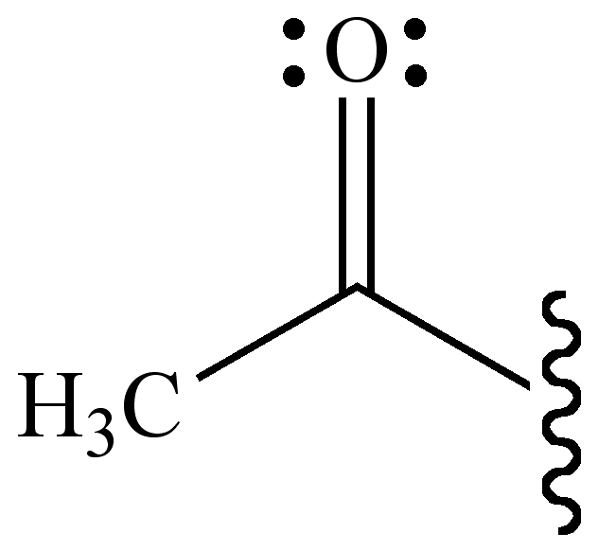

Acetylation of histone proteins removes positive charges. this reduces the affinity between histones and DNA making RNA polymerase and transcription factors easier to access the promoter region of the DNA. Histone acetylation enhances transcription while histone de-acetylation represses transcription.
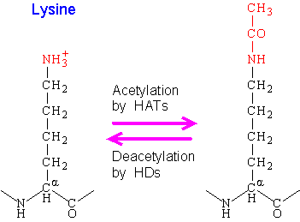
Figure 4-G-1. Acetylation and deacetylation of the lysine residue.

DNA METHYLATION: The addition of a methyl group (-CH₃) to a nucleotide. The effect is usually to turn off or silence the gene. It may impede the attachment of polymerase enzymes so stopping the production of RNA. 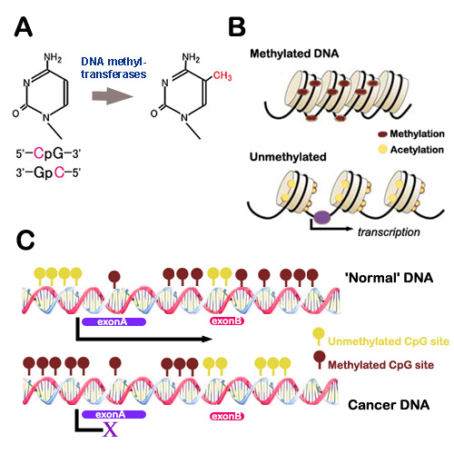

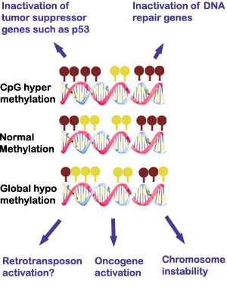
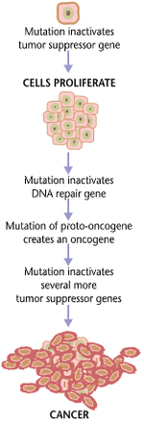
(TRANSLATION ANIMATION GOOGLE SEARCH NINTENDO ANIMATION: + CENTRAL DOGMA DNA TO RNA ANIMATION)

RIBOSOMES: SITE OF PROTEIN SYNTHESIS
Consists of :
- Several types of rRNA
- 70 kinds of polypeptides
- Two subunits
Made in
- Nucleolus: area in the nucleus
Nucleolus can make several 1000rib/hr
Ribosomes:
Two subunits of ribosomes
- Small subunit
- Large subunit
These two parts only come together during protein synthesis.
Ribosomes of : prokaryotes, plastids, mitochondria are similar but smaller than eukaryotes
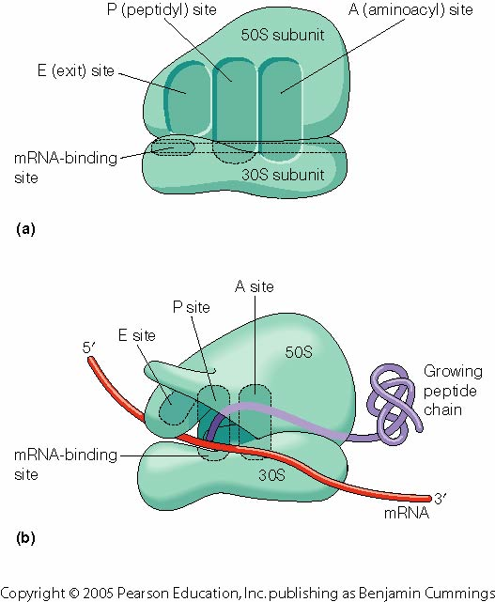

Transfer RNA : tRNA

Transfer RNA carries amino acids to the ribosomes. Each AA has a specific tRNA molecule to transport it.
-All tRNA molecules have roughly the same shape but their nucleotide sequences differ.
The most important areas on the tRNA are….
- Aminoacyl attachment site: amino acid attaches here
- anticodon: is 3 nucleotide sequence that is complementary to the codon on the mRNA

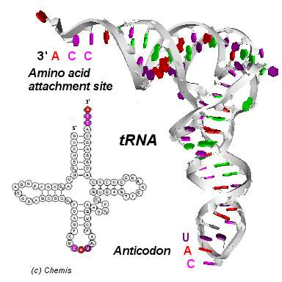

Transfer RNA (tRNA)
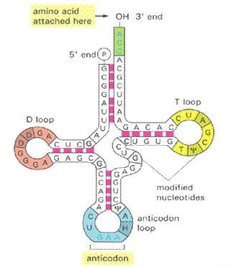">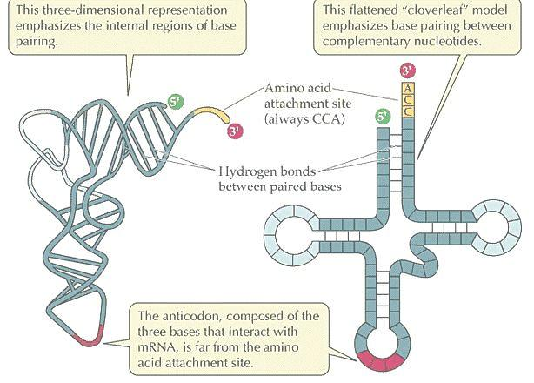

PROTEIN SYNTHESIS: (translation)
The formation of peptide bonds (covalent) between aminoacids to produce a polypeptide and then a protein.

Before protein synthesis can occur several events must occur. (INITIATION)
- mRNA binds to the small ribosomal subunit
- The 1st codon (AUG) pairs with the anticodon of the
tRNA w/ AA methionine (1st AA in polypep.)
- Now the large ribosomal subunit binds to the
complex
- These initiation steps are complete and peptide chain
can now be made.
Ribosomes have two main sites P site and the A Site
- The AUG codon attaches at the “P site” the 2nd mRNA codon is at the A site

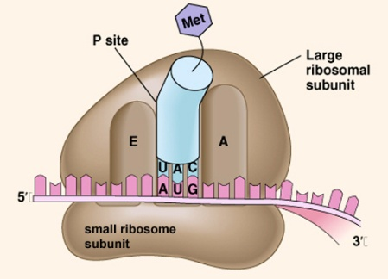
3 steps bring in the next AA and join it.(know pg 169 old)
- tRNA binds to mRNA codon at the A site.
- Enzyme joins the two AA together by a peptide bond
- Translocation occurs: 2nd tRNA and its mRNA codon move to vacated P site.

- Each mRNA molecule may have over 100 ribosomes attached to it.
- Average life span of mRNA = 2minutes
TERMINATION:
Polypeptide grows until it reaches a stop codon
UAA , UAG, UGA + causes mRNA to leave rib.
- After leaving ribosome methionine and some neighboring AA must be removed some chemical groups may be added , sulfur bridges formed.

CONTROL OF PROTEIN SYNTHESIS
- Control of protein syn. is regulated by controlling transcription of RNA.
- Many genes are turned on and off. Some genes are always on.
- Gene Regulatory proteins – Protein agents that turn genes on or off transcription
( can be inhibitors or promoters of trans.)
- Some of thess GRP bind to specific parts of DNA and keep RNA polymerase from binding so prevent transcription.

OPERONS:
Genes for related enzymes (proteins) located on a single stretch of DNA that operates as a single unit.
Usually consists of :
- Structural genes: appr. 3 – 5
Can be enzymes
- Control genes: control the production of structural genes
- Regulator gene
- Promotor gene
- Operator gene

- Regulator gene :
Produces mRNA that is translated into a regulatory protein
- Promotor Gene:
Site where RNA polymerase binds to the DNA for the purpose of coding mRNA for the structural genes
- Operator Gene
Is the binding site for the regulatory protein (coded for by the regulator gene )
OPERONS USUALLY CONTROL A SERIES OF GENES THAT PRODUCE ENZYMES OR OTHER STRUCTURAL PROTEINS
LAC OPERON: ( Described by two French geneticists in 1961 Jacob-Monod)
(found in E. Coli bacteria)
(CODES FOR 3 ENZYMES THAT BREAK DOWN LACTOSE SUGAR)
The regulatory gene lacI produces an mRNA that produces a Lac repressor protein, which can bind to the operator of the lac operon.
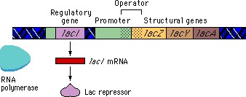
The lacI regulatory gene is called the lacI regulator gene.

Regulatory genes are not necessarily close to the operons they affect.
The general term for the product of a regulatory gene is a regulatory protein.
-The Lac regulatory protein is called a repressor because it keeps RNA polymerase from transcribing the structural genes.
-In the absence of lactose, the Lac repressor protein binds to the operator and keeps RNA polymerase from transcribing the lac genes.

-It would be wasteful for E. coli if the lac genes were expressed when lactose was not present.
The effect of the Lac repressor on the lac genes is referred to as negative regulation.

Repressible and inducible operons

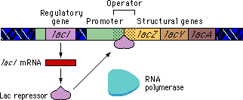

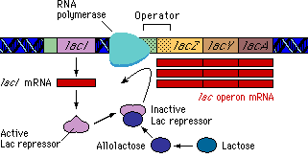A
Lactose binds to an allosteric site on the repressor protein causing a conformational change. As a result of this change, the repressor can no longer bind to the operator region and falls off.
- RNA polymerase can then bind to the promoter and transcribe the lac genes.

NOTE : the Regulator gene can be some distance from the rest of the genes on the chromosome

LAST SECTION: RANDOM STUFF TO KNOW
-Histones (are proteins found only in eukaryotic) don’t prevent transcription
-A spliceosome is a complex of RNA and protein subunits that removes introns from a transcribed pre-mRNA segment. This process is generally referred to as splicing.
- Snrps : small nucleic ribonucleotide proteins that are involved in cutting out introns and turning them into a spliceosome
Introns are not found in prokaryotic cells
- Methylation: addition of a methyl group ( keeps genes turned off)
-In some prokaryotes parts of turned off genes are still transcribed called ( leaky genes)
-Methylation doesn’t occur in prokaryotes. Not worthwhile because they don’t live long enough.
-Polytene chromosomes:
Giant chromosomes containing hundreds of strands of DNA. Fig 10-15 old b. Drosophila Melanogaster (frt. Fly)
Apoptosis: programmed cell death (in cancer cells they no longer die) . It plays a crucial role in developing and maintaining health by eliminating old cells, unnecessary cells, and unhealthy cells. The human body replaces perhaps a million cells a second.

CONTROL OF GENE ACTIVITY DURING EMBRYONIC DEVELOPMENT
- Genes are switched on and off throughout life, but the most dramatic examples occur during development of an embryo.
- Most multi-cellular organisms start life as a single cell.
- As cells of the embryo divide they “Differentiate” into all of the different cells, tissues, and organs. They do this by having different genes switched on and off
TOTIPOTENT (pluripotent)cells: a cell that has the ability to differentiate into any tissue ( true for zygote)
MULTIPOTENT cells : Cells from adult tissue that can differentiate into a limited number of other tissues: ( human adipose(fat) tissue: diff. into smooth muscle tissue)
METAMORPHOSIS:
An abrupt alteration in an organisms anatomy + physiology as it changes from larvae to adult.
Adult and young have very different life styles
Adult = sexually mature
- All metamorphic changes occur as a result of gene activity.
- Amphibians: Brought about by the hormone THYROXINE secreted by the thyroid gland.
This hormone must be present for metamorphosis to occur. (Thyroxine hormone is also important in maturation in mammals as well)
- Insects: JUVENILE HORMONE : controls metamorp. in insects. In the presence the insects do not metamorphose. ( possible control of adult insect pests)
CANCER:
Most cells in the body divide only when needed.
TUMOR:
A clump of cells that grows and divides rapidly and abnormally.
Benign Tumor: Don’t invade other tissues: harmless.
Malignant tumor:
Cells continually dividing. Can invade other tissues and organs destroying their function.
Cancer: is malignant tumors

-A cancer starts when a single cell is transformed into a cancer cell by undergoing mutations in some of the genes that control cell division. This cell then continues to divide producing clones. Genetically identical cells which become a tumor.

-Metastasis: Process where malignant cancer cells break off and travel to different parts of the body and start new tumors.

-Cancer cells do not obey signals:

Some genes are responsible for stopping cell division. These genes may have been damaged, lost or mutated.

Cancer cells do not stick together (contact inhibition)
Cancer cells can lose the molecules on their surface that keep normal cells in the right place. So they can become detached from their neighbor cells( metastasis)

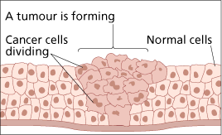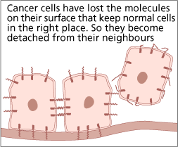

It is theorized that 3-7 changes in the DNA must occur for a cell to become cancerous.

Step 1: Mutation
Step 2: This mutation is passed on to further generations
Step 3: accumulation of changes

CANCER CAUSING AGENTS:
Carcinogens: exposure causes increase risk of cancer
Mutagens: exposure causes increase risk of mutations
and thus can lead to cancer.

- Most carcinogens are mutagens but a few are not: They trigger cancer by turning on genes that are already mutated.
MUTATED GENES IN CANCER CELLS
2 GROUPS:
- Tumor suppressor genes:
When these genes are mutated they no longer suppress the production of a variety of proteins and now the cell makes proteins uncontrollably and divides rapidly.
- Oncogenes
- Arise by mutation of normal cellular genes, these genes are called proto- oncogenes.
(Proto-oncogenes control the production of proteins that stimulate growth and cell division.)

A proto-oncogene is converted to an oncogene by a mutaton that causes or produces extra copies of the gene or increases the expression of the one gene.
Approximately 60 proto- oncogenes known.

Note: some viruses can cause cancer
( Leukemia is the first cancer shown to be caused by a virus.)
Viruses join a host cells genome and may go into a latent period for days or years.

Cancer 2nd most common cause of death

Cancer removal
Benign - surgical
Malignant- chemotherapy, radiation treatment

