***Ecology Youth Corps***

***-Now Hiring for Summer-***

Fill out your on-line application NOW at:

[**www.ecology.wa.gov/EYC**](http://www.ecology.wa.gov/EYC)

***DEADLINE: Monday, April 3, 2023, 5:00 PM***

***\*must be received in our offices – no postmark)***

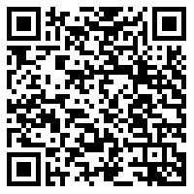

***QUESTIONS? Call the Eastern Regional Office at (509) 329-3400***

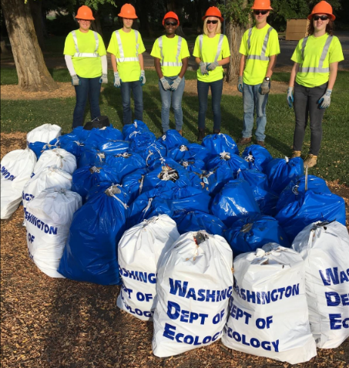 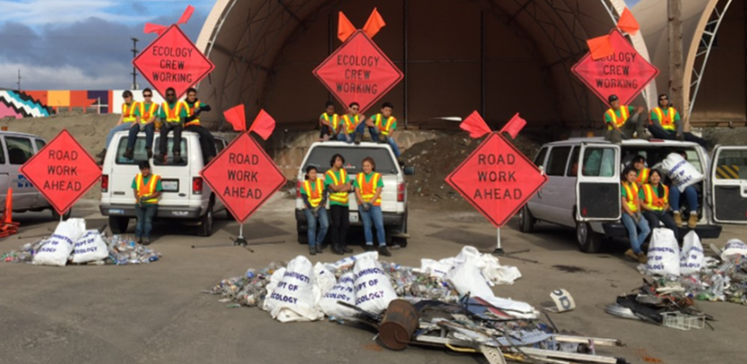

Per Governor Inslee’s [Proclamation 21-14.2,](https://www.governor.wa.gov/sites/default/files/proclamations/21-14.2%20-%20COVID-19%20Vax%20Washington%20Amendment%20%28tmp%29.pdf) Washington State employees must be fully vaccinated against COVID-19. Successful candidates must provide proof of vaccination, before their start date. We will consider requests for medical and religious exemptions.  
  
For questions, email [careers@ecy.wa.gov](mailto:careers@ecy.wa.gov?subject=COVID-19%20Vaccination)

The Washington State Department of Ecology is an Equal Opportunity Employer and does not discriminate on the basis of race, creed, color, disability, age, religious national origin, sex, marital status, disabled-veteran status, Vietnam-Era veteran’s status or sexual orientation. For special accommodation needs, please contact the Employee Services Offices at 360-407-6186.