

**Health and Fitness Class Syllabus**

Welcome to 7th and 8th grade Health and Fitness! I hope you all have had a healthy and wonderful summer and are ready to get moving! This syllabus will give you a better understanding of our class format, including grading policies, activities, and other requirements. We will be completing the following curriculum for the upcoming school year…

**Weekly Plans:**

**August-September**: Games 4 Days a Week and Fitness Friday.

**November-March**: Health Education 2 Day a Week, Games 2 Days a Week and Fitness Friday.

**April-June;** Games 4 Days a Week and Fitness Friday.

**Grading Policies:**

**Daily Performance Grade**: (50% of your Grade)

The majority of a student’s grade is derived from their daily active participation in the classroom setting. For this reason, students need to actively participate in all class activities to earn credit towards the performance portion of their grade. In order to participate, students need to be dressed appropriately for physical activity, including athletic clothing and footwear. Students can then maximize their daily grade through active participation, engagement in skill development, and demonstration of appropriate social behaviors (respect, sportsmanship, etc.).

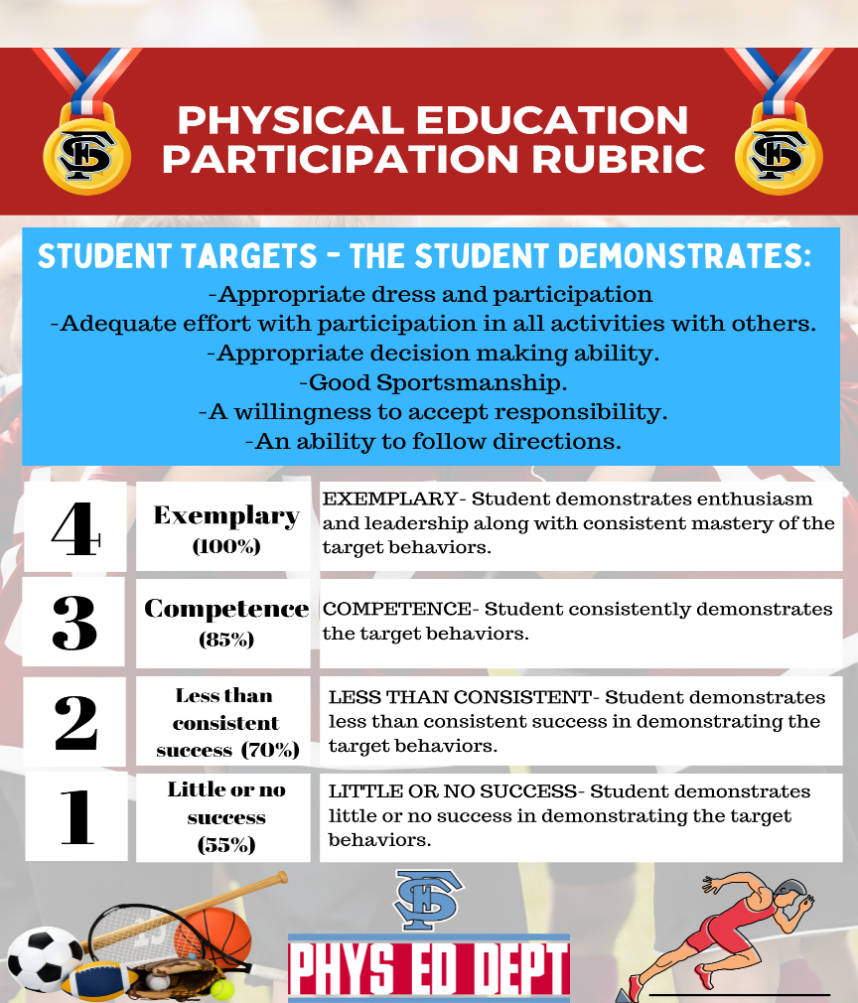**Daily Grade Notes:**

NFD- Not Following directions

TWP- Talking without Permission

TO- Time out

A- Absent

NS- Not correct clothes

NP- not participating

NME- Needs more effort

**Health/Tests:** 40%of your grades is based on completed class work, and assigned homework. Any quizzes and tests will be additional points for that week.

**Fitness Testing**; 10% of your grade is based on fitness scores according to gender and age.

You will have an opportunity to have improvement points.

**MAKE UPS:** PE make ups are available on google classroom. One makeup workout for every day you miss in PE. Health assignments are posted on Google classroom. **You have one week to make up assignments or absences and will receive a -10% deduction**.

**Activities and Units**:

**PE:** Throughout the year, units may include but are not limited to the following: Tennis, Pickleball, Badminton, Basketball, Softball, Kickball, Baseball, Dance, Flag Football, Frisbee, Volleyball, Team Handball, Soccer, and Floor Hockey.

**Health:** Throughout the year, units may include but are not limited to the following: Bullying and Harassment, Values, Goal Setting, Peer Pressure, Alcohol, Tobacco, Illicit Drugs, Muscular and Skeletal Systems, Circulatory System, Nervous System, Endocrine System, Respiratory System, HIV/AIDS Education, Nutrition, CPR and First Aid, and Personal Hygiene.

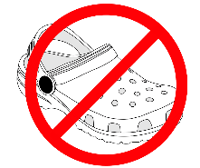**Required Materials: 7th and 8th Grade ONLY**

**PE:** Clothes worn for activity classes must be different from clothes worn to school. Acceptable clothing includes athletic shorts, a short-sleeve or long sleeve athletic t-shirt, socks, and running or cross training shoes. Shoes with rollers, Slippers, Crocs or Boots up are not allowed.

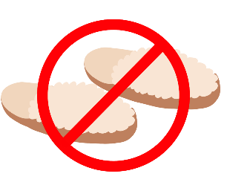**NO CROCS, SLIPPERS, SLIDES OR BOOTS!**

If you do not have proper clothing you will have to opt-out and receive a NS for the day (zero for the day).

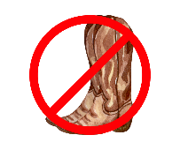**Health:** Mr. Cochran= Monday-Tuesday in portable; Mr. Neely/Mr. Garner= Wednesday- Thursday in his classroom. We will not start health until November and finish in March. Students need to bring a laptop, paper, pen/pencil, paper and free-time reading material for each health class.

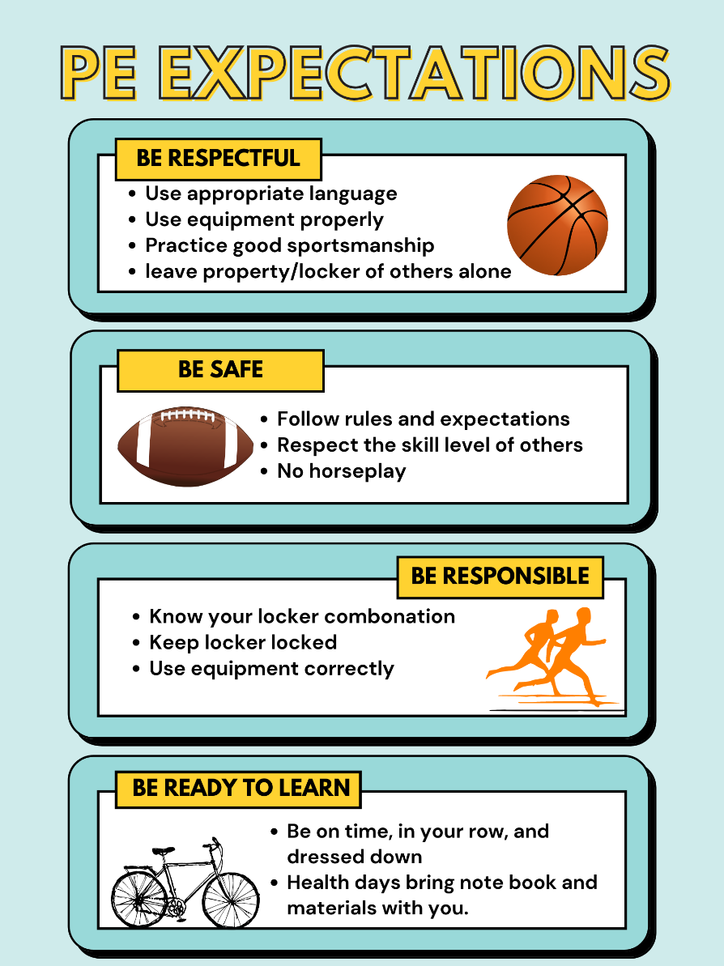**Special Accommodations and Limitations:**

If a student cannot perform at the level expected for the class requirements for grading, the instructor must be notified by a parent or doctor with an explanation of medical conditions or physical limitations. Students may be excused from physical activity participation temporarily if the instructor receives notification with specific information detailing the nature of the injury or limitation and the expected duration. A parent, guardian, or doctor may notify the instructor by phone, email, or written note. Students are responsible for completing a Fitness and Health Make-up Form (found on google classroom) for any missing activity days.

**Lockers:**

7th and 8th Grade students will be assigned a fitness locker with a built-in combination lock. Students are not to give out their locker combination to other students. Students may not use a personal padlock. Students should label clothes and lock materials only in their assigned locker.

**Excuses and Notes**

If a student is unable to participate in PE a parent may write a note.  Notes should include: **student’s name (first and last), period, date to be excused, reason for the excuse, parent/guardian signature, and a day time phone number**.  If a student is very sick or injured and needs to be excused from physical education for more than two days a doctor’s note is required.  Students are required to dress out even when they have a written excuse.  Students with a note that are unable to participate in PE will have their points for the day deducted from their grade, and students may do make up sheet to earn their points back.

**Doctor notes**:

Doctor’s notes are required for any injury or ailment that will require the student to miss more than 3

consecutive days of participation in physical education. The student will be given alternate/modified

assignments to do during class. Specific activities/assignments may require make-up when the student is

healthy/able.

­­­­­­­­­­­­­­­­­______________________________________________________________________________

**Signatures**

Both student and parent/guardian need to sign the syllabus and video permission sections and bring it to your instructor to receive 10 points. This will be your first grade of the semester in Health and Fitness.

I am looking forward to having a great year in Health and Fitness! Please contact me with any questions!

Student Name: ____________________ Student Signature: ______________________ Date: ____

Parent Name _____________________ Parent Signature: _______________________ Date: ____­

If you have any questions or concerns, please contact me at:

Mr. Cochran (7th and 8th grade) - [bcochran@freemansd.org](mailto:bcochran@freemansd.org)

Mr. Neely (1st semester 6th grade) – [kneely@freemansd.org](mailto:kneely@freemansd.org)

Mr. Garner (2nd semester 6th grade) – [ngarner@freemansd.org](mailto:ngarner@freemansd.org)

Thank you!