WAVES AND LIGHT

1. TYPES OF WAVES: (2 TYPES IN NATURE)
   1. Mechanical waves ( water waves, sound)
   2. Electromagetic waves ( light ,

Energy can be transferred by particles or by waves

Waves behave with specific rules:

1. Reflection off a barrier or boundary
2. Can bend around objects (diffraction)
3. Bend when they pass into a new media(refraction)
   * 1. **Mechanical waves**: need a material medium through which to transfer energy
     2. **Electromagnetic waves**: Need no medium to transfer energy through: Waves of energy that have both a magnetic and electric fields

*Website wave motion*

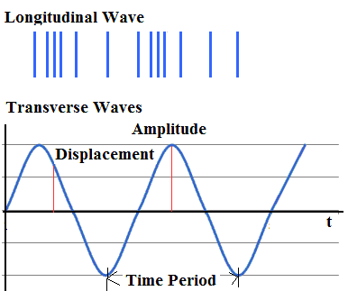

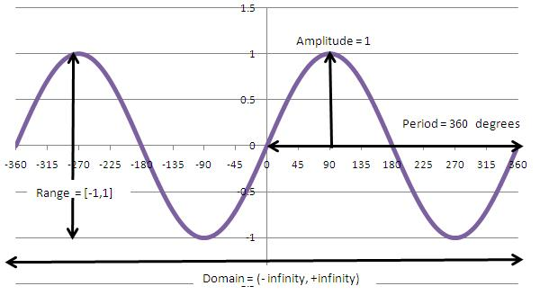

Two types of wave motion:

1. **Transverse waves:** particles vibrate perpendicularly to

the direction the wave is traveling ( water waves)

NOTE: Transverse waves usually are **sine waves**: the source vibrates with simple harmonic motion. So there is a periodic motion of the energy

1. **Longitudinal waves:** (compression waves) particles vibrate parallel to the direction the wave is traveling ( sound waves)

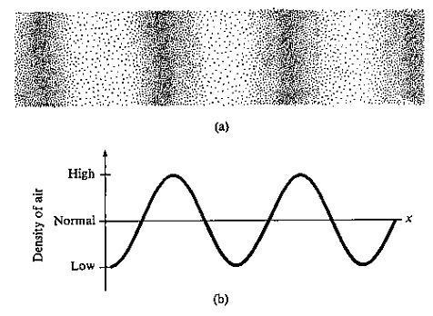

Example of sound wave turned into a sine wave on an oscilliscope

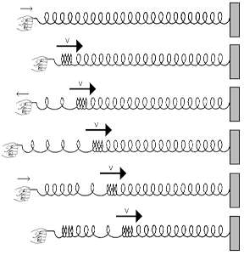

**Wave terminology :**

**Pulse:** is a single wave disturbance

**Wavelength**: ( λ ) The distance between corresponding points on two adjacent wave disturbances.

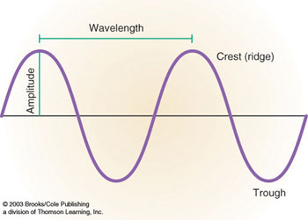

**Crest:** the high point of displacement on a transverse wave (greatest displacement)

**Trough:** The greatest point of displacement below the zero point of a wave medium.

**Amplitude:** The amount of energy a wave pulse carries measured by the displacement of the wave pulse from the point of rest.

**Period of a wave**: (T) The time it takes for one wave pulse to pass a given point

**Frequency**: The number of wave pulses that pass a given point in a given amount of time. ( usually per second)

*f* = 1/T

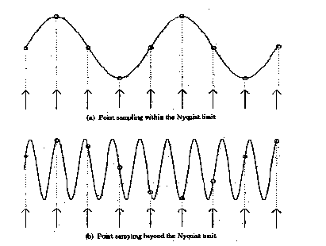

Above if both wave series are traveling at the same speed which

1. Has a greater frequency?
2. Has a greater wavelength?
3. Has a greater amplitude?

**Wave speed :** measured in meters per second

V= ΔX/ΔT so V= λ/T if *f* = 1/T then

V= *f* λ for electromagnetic waves

C=*f* λ

Calculated by V= (*f* ) ( λ)

Pg 387 1- 4 new Pg 449 pr 1-6 new Old 237 1-8

Frequency and period are inversely related

The greater the period the smaller the frequency

**Wave interactions:** When waves interact, after they have passed one another they continue on with no change in energy from the interaction **.**

Interference: When waves cross, their displacements are superimposed.

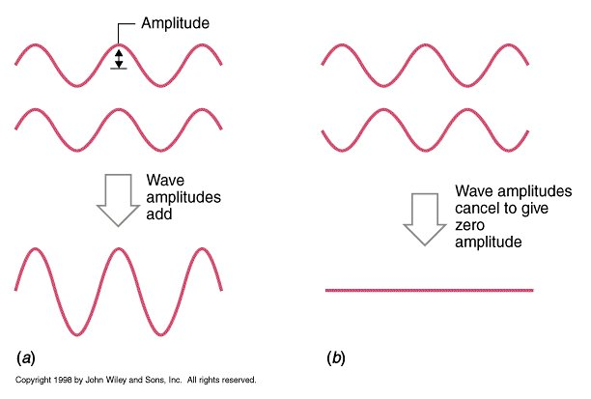

Constructive interference: Amplitudes are in phase so they add together to have a larger amplitude

Destructive interference: amplitudes are out of phase so they cancel out

**Standing waves:** a resultant wave pattern that appears to be stationary caused by alternating constructive and destructive interference. ( sea monsters)

**Node:** The point during interference that is left undisturbed at all times

**Antinode:** point of greatest displacement

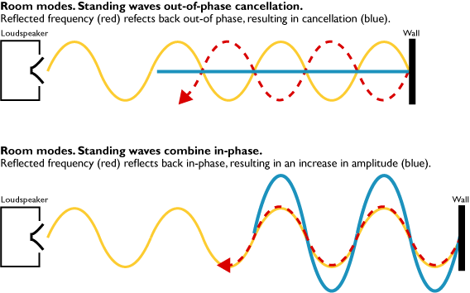

**Wave speeds in different media:**

Mechanical waves:

1. Passing into a more dense medium will have an increase in speed (Sound travels faster in water than air)
2. Passing into a less dense medium will have a decrease in speed ( sound travels slower in air than in water)

Electromagnetic waves: ( light, electric, xray etc)

1. Travel faster in a less dense medium
2. Travel slower in a more dense medium
3. 3 X 108m/s in a vacuum. Everything after is downhill.

Slower. ( air: we say 3 x 108m/s )

Note: when a wave meets a boundary, some may be reflected some may be transmitted. The greater the difference in media the greater reflection.

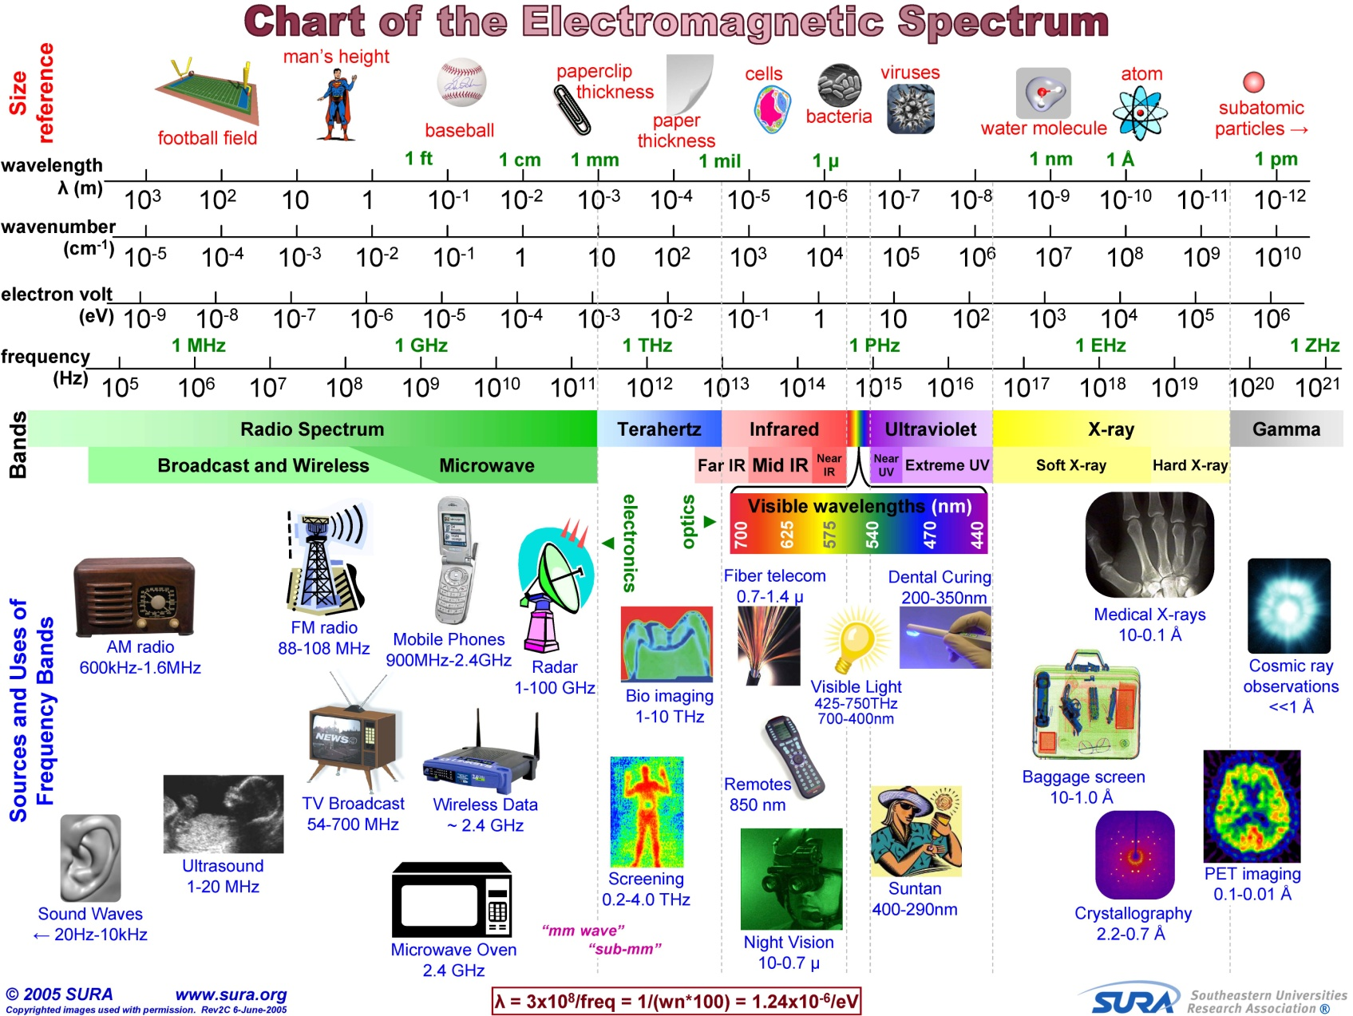

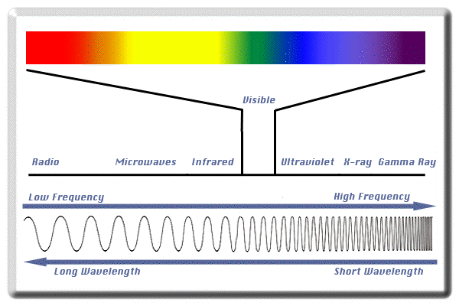

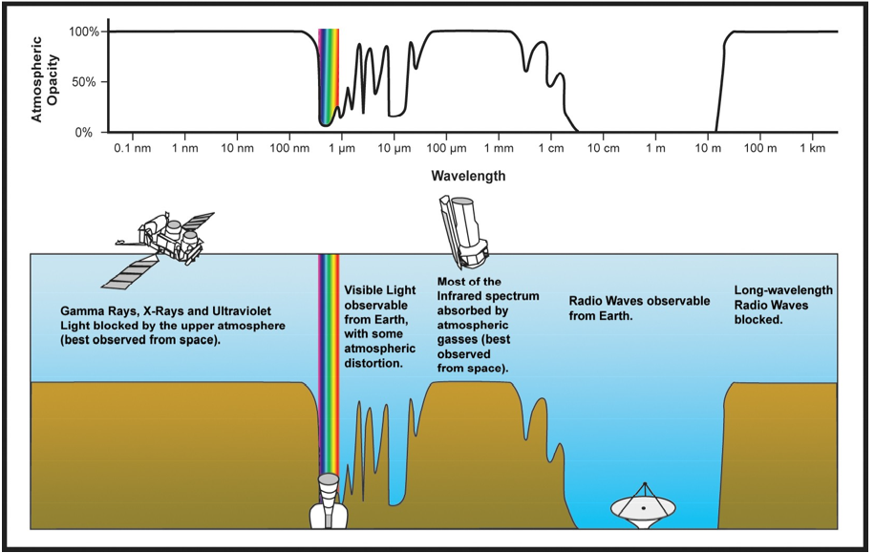

1. Three changes in wave direction:
   1. Reflection b. Refraction c. Diffraction:

**Law of reflection:**

The angle of incidence is equal to the angle of

Reflection

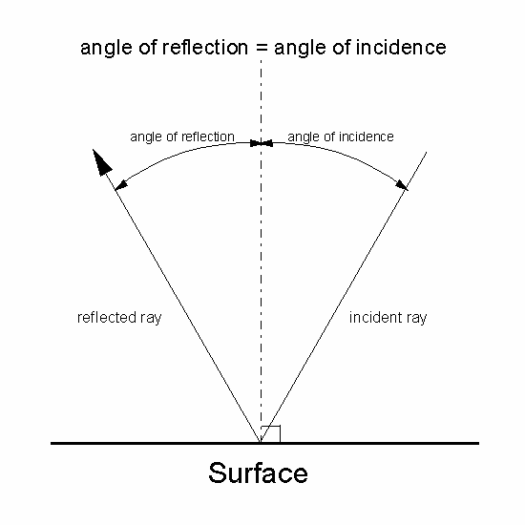

Dashed line is the **normal** to the surface( perpendicular)

The lines on the diagram above represent wave series or pulse and are called **Rays.**

**Total internal Reflection**:

Occurs when light falls on the surface of a less optically dense medium at such an angle that no refracted ray may be produced.

The angle of incidence that allows the refracted ray to lie along the border of the boundary is called the **Critical angle**

() Ic

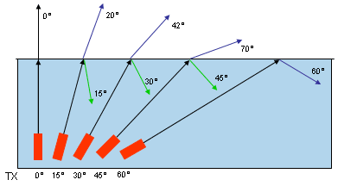

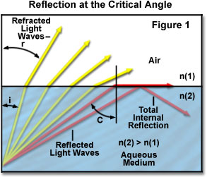

**Refraction:**

The bending of waves when they pass into a new medium . (effects: rainbow, heat waves, puddle effect)

When wave fronts approach a parallel boundary to another medium at an angle other than 90 degrees. The first part of the wave has its velocity change and thus the wave bends due to the change in density of the new medium. ( wave son a beach, optics)

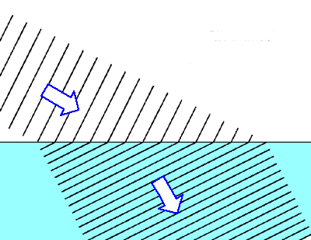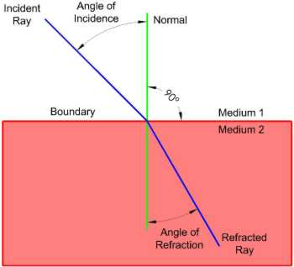

Pg 286 8-10 old book

**Diffraction:** The bending of a wave around an obstacle .

( light coming into a dark room from a door slightly

Open, water waves around a rock in the water)

Optical Density: property of the medium that determines the speed of light in the medium. ( more optically dense, the slower the lights velocity)

Light will bend toward the normal if its velocity slows down and away from the normal if the velocity speeds up.

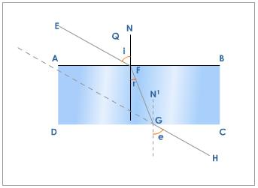

Snell’s Law:

For a given medium a ray of light bends in such a way that the ratio of the sine of the angle of incidenc to the sine of the angle of refraction is a constant. n this is called the index of refraction: each medium has a different index of refraction

n= Sin i for any two media Snell’s law may be

Sin r written as n1Sin I = n2 Sin r

ns = c where c = speed of light in air

vs vs = speed of light in other media

so if the index of refraction is known ns then to find the speed of light in that medium rearrange above equation to

Vs = c Prob 1 pg 282 old

ns Prob 2-6 pg 284 old book

Prob 8-10 pg 286 old book

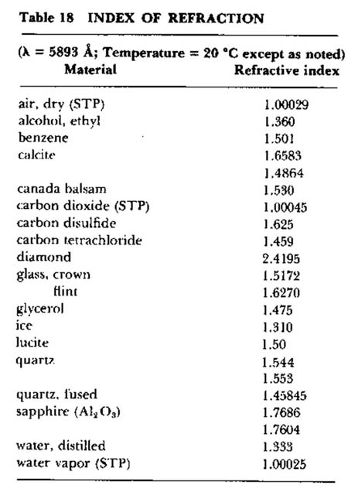

Diffraction

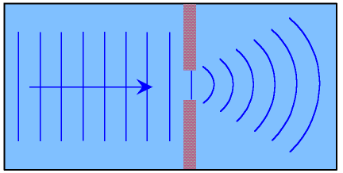

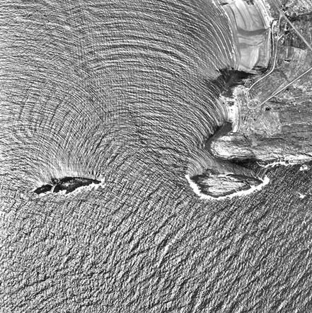

Transmission and absorption of light:

1. Transparent material
   1. Transmit light w/o distorting the rays
2. Translucent material
   1. Transmit light but light rays are distorted

Ex. lamp shades

1. Opaque material :
   1. Substances that don’t transmit light. They either reflect or absorb them.

**Doppler Effect: (Show video)**

A change in the observed frequency of waves when

a wave source and an observer are in relative

motion.

λ is shorter in front of the moving source and

longer behind the moving source.

Ex. sonic boom is caused by the Doppler effect

Ex. Red shift of stars: caused by the Doppler effect

[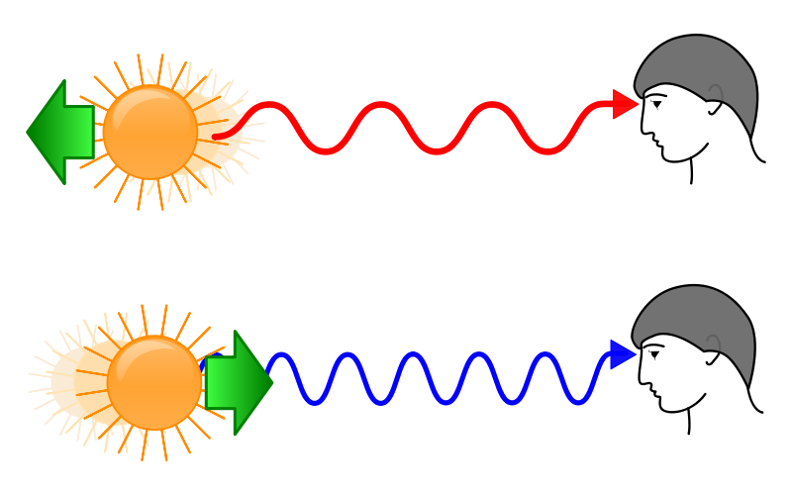](http://upload.wikimedia.org/wikipedia/commons/e/e4/Redshift_blueshift.svg)

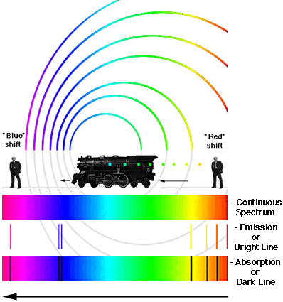

Why do stars appear to change color sometimes?

Has to do with the refraction of light through the atmosphere. Lights are separated out similar to a prizm.

Pg 397 pr 35 , 36, 37,39 Pg 255 old book Q 1-21 Pg 256 pr 1-9