**Unit 10- Mirrors and Lenses**

1. **Mirrors**

3 types a. Plane mirrors b. Converging mirrors c. Diverging mirrors

1. **Plane Mirrors:**
   1. All light rays will be reflected from the mirror in the same way

NOTE: All mirrors reflect rays in accordance with the law of

Reflection

**Rules for images: 2 rules**

1. Images in plane mirrors
   1. Appear behind the mirror the same distance that the

Object is in front

* 1. Will be the same size as the object
  2. Will be reversed right for the left
  3. Will be a virtual image and will be erect

1. **Converging mirrors:**

A concave mirror in which parallel rays when reflected will converge. (cross at some point)

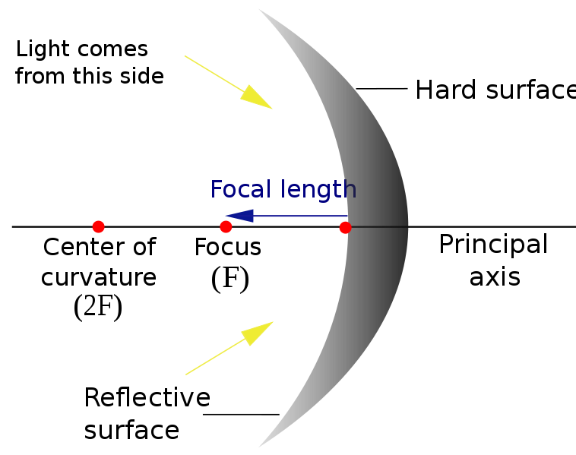

Terminology

**Focal point: (F)** the point at which rays converge and

intersect . Halfway between the center of curvature

and the vertex of the mirror.

**Center of curvature: (C)** the center of the circle if the mirror

was extended to form a circle

**Vertex:** the geometric center of the mirror

**Principle Axis:** an imaginary line extending from the vertex to

the center of curvature

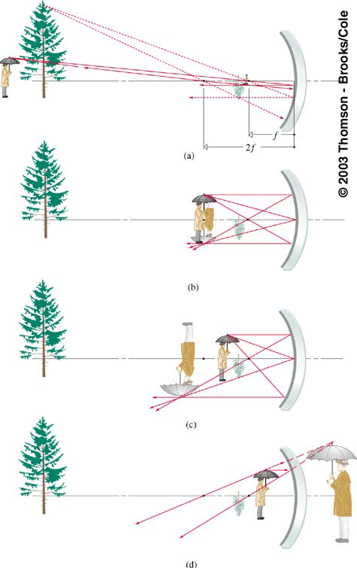

**For Converging mirrors you can have**

Real or Virtual images

Images smaller, larger , or the same size as the object

1. Draw a line from object parallel to the PA then thru F
2. Draw a line from object thru F then reflected parallel to the PA
3. Draw a line to the pa then reflected according to the Law of reflection
4. Where they intersect will be where image is formed
5. **Diverging mirrors: (Convex mirror)**

A convex mirror in which parallel rays will diverge

That is spread out..

Images formed by diverging mirrors are always

1. Virtual
2. Erect
3. Smaller than the object

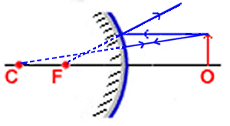

Finding distance and size of images in a mirror

If the objects distance and the Focal length are known we can calculate the position of the image in a mirror

1 + 1 = 1

do di f

Ex.

Where is the image formed by a converging mirror if the object is at 10cm and the focal length of the mirror is 5cm?

Calculating magnification:

The ratio of the image size to the object size is called

Magnification.

Si = size of image So= size of object

di =distance of image do= distance of object

Si = di

So do

Ex. What is the size of the image and distance if the object is 10cm away from a mirror with a F = 3cm?

Pg 301-303 prob 1-10 old

Pg 306 prb 11-14 old

**Where will images appear for concave mirrors?**

1. Object is between C and F

Image

* 1. Appear beyond C
  2. Be larger
  3. Be real
  4. Be inverted

1. Object beyond C the image will…
   1. Appear between F and C
   2. Be smaller
   3. Be inverted
   4. Be real
2. Object at C, image will
   1. Be at 2F
   2. Same size
   3. Inverted
   4. Real

**Spherical Aberration:**

In perfectly spherical mirrors, rays that strike the mirror along

the outer edge miss the focus. Therefore the image formed

is fuzzy.

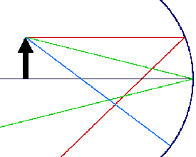http://www.4physics.com/images/x.gif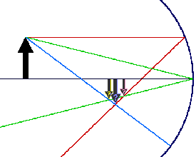

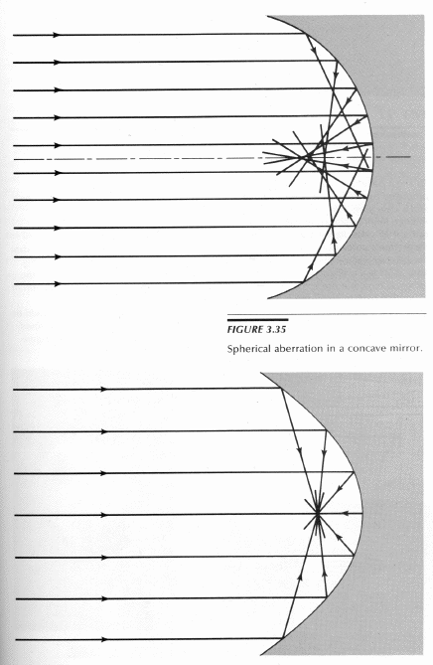

Real vs virtual images

Virtual image: (formed by convex, concave, plane mirrors)

Light rays do not pass through

Image is appears behind the mirror

Image is reversed right to left

Image is erect

Real image( formed only by concave mirrors)

Light rays pass through image

Image is inverted

Lenses: Converging and diverging

**Converging lenses( convex)**

Lens that is thickest at its middle

Cause rays that are approaching parallel to the principle axis

of the lens to converge at the focal point due to refraction.

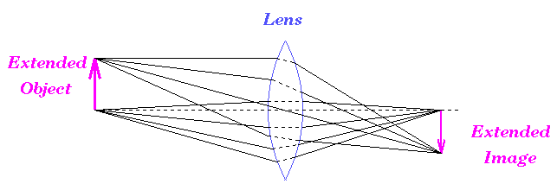

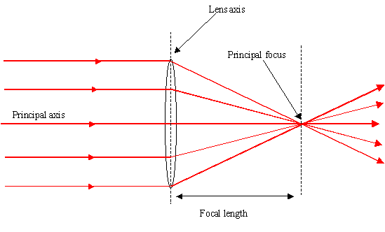

The focal length depends on the shape and index of refraction of the lens

1. Shape: thicker in the middle more refraction so shorter F
2. More optically dense, more refraction

Symmetric lenses have focal points on both sides of the lens

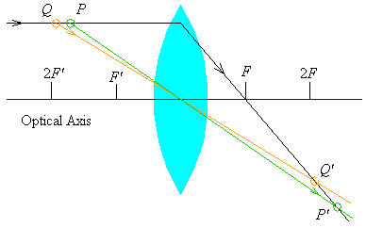

IMAGES FORMED BY CONVERGING LENSES

Object is

1. Beyond 2F
   1. Image is between F and 2F
   2. Real and inverted
   3. Smaller than the object
2. Object at 2F
   1. Image is at 2F
   2. Real and inverted
   3. Same size as object
3. Object between 2F and F
   1. Image is beyond 2F
   2. Real
   3. Inverted
   4. Larger than object

**Real images in converging lenses**

1. Draw a ray parallel to the principle axis. It will pass through the lens and go thru focus on opposite side
2. Draw a ray from object that passes through focus then the lens and will run parallel on the other side
3. Where they cross is where the image is formed .

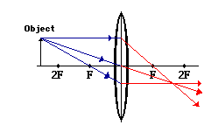

Virtual Images fromed by converging lenses

1. Erect 2. Virtual 3. Larger

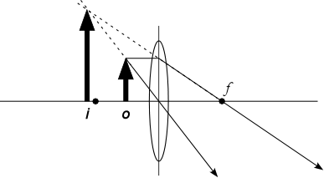

**Diverging lenses :**

Concave lenses : thinner at the center : light rays diverge

Images formed are always 1. Virtual 2. Erect 3. Smaller

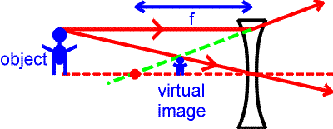

CHROMATIC ABERRATION :

As light passes through a lens, different λ of light are refracted at slightly different angles. Any objec observed thru a lens appears ringed with color

Chromatic aberration limits the sharpness of the image

Some lenses can be treated with a substance that has a different index of refraction . this cancels the chromatic ab. These lenses are called achromatic lenses.

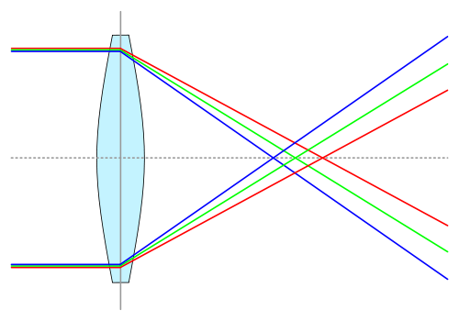

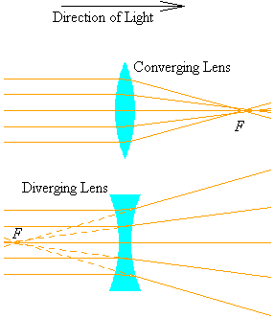

**How the eye works:**

For a normal eye, the image is formed on the retina. It is real and inverted.

What happens for people that are nearsighted or farsighted?

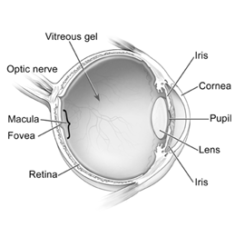 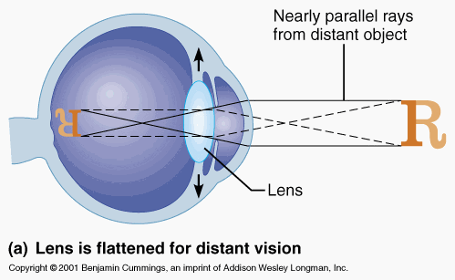

). **Focus**

A). For **far-sight (seeing things far away)** the lens is **relaxed**

Eye is preset to farsightness is caused by loss of elasticity).

B). For **near-sight** (seeing things near to by) the lens is **bent**.

|  |  |
| --- | --- |
| bullet | contraction of cilliary muscles |

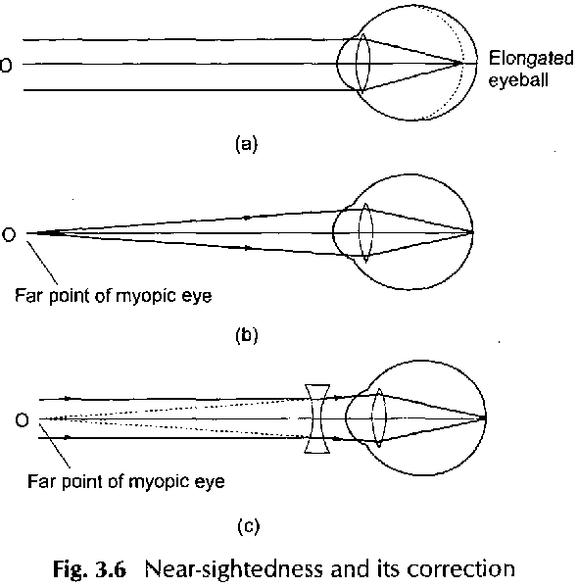

The lens of the eye helps the cornea focus light on the retina. Because the lens can change shape, it is capable of helping the retina focus on distances near and far.  
  
The vitreous( vitreous humor) is a clear jelly like substance that acts as filler because it fills the inside of the eye between the lens and the retina. The vitreous is composed mostly of water and makes up two thirds of the eye's volume.

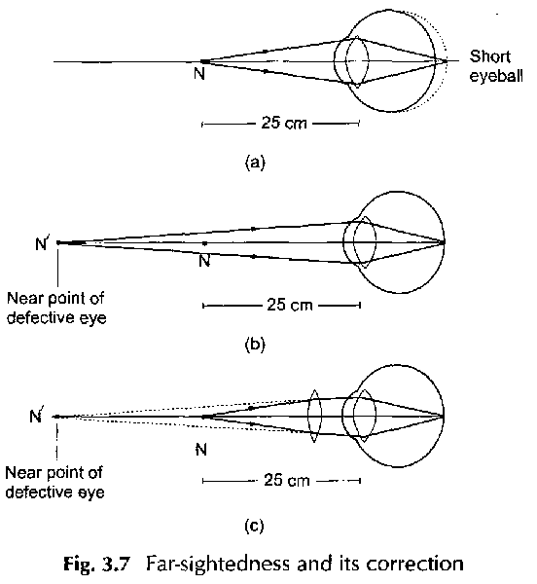

Pg 310 pr 22,23

Pg 314 Q 1-5

